Phase-2-Week-6 Home Assignment:
Based on the provided architecture file, you are required to develop both the backend and frontend components.
Backend:
LangChain must be used mandatorily.
Frontend:
The application should provide an option to upload multiple files and allow users to ask questions based on the content of the uploaded files.
The system should return answers derived from those file contents.

LangChain is used mandatorily.
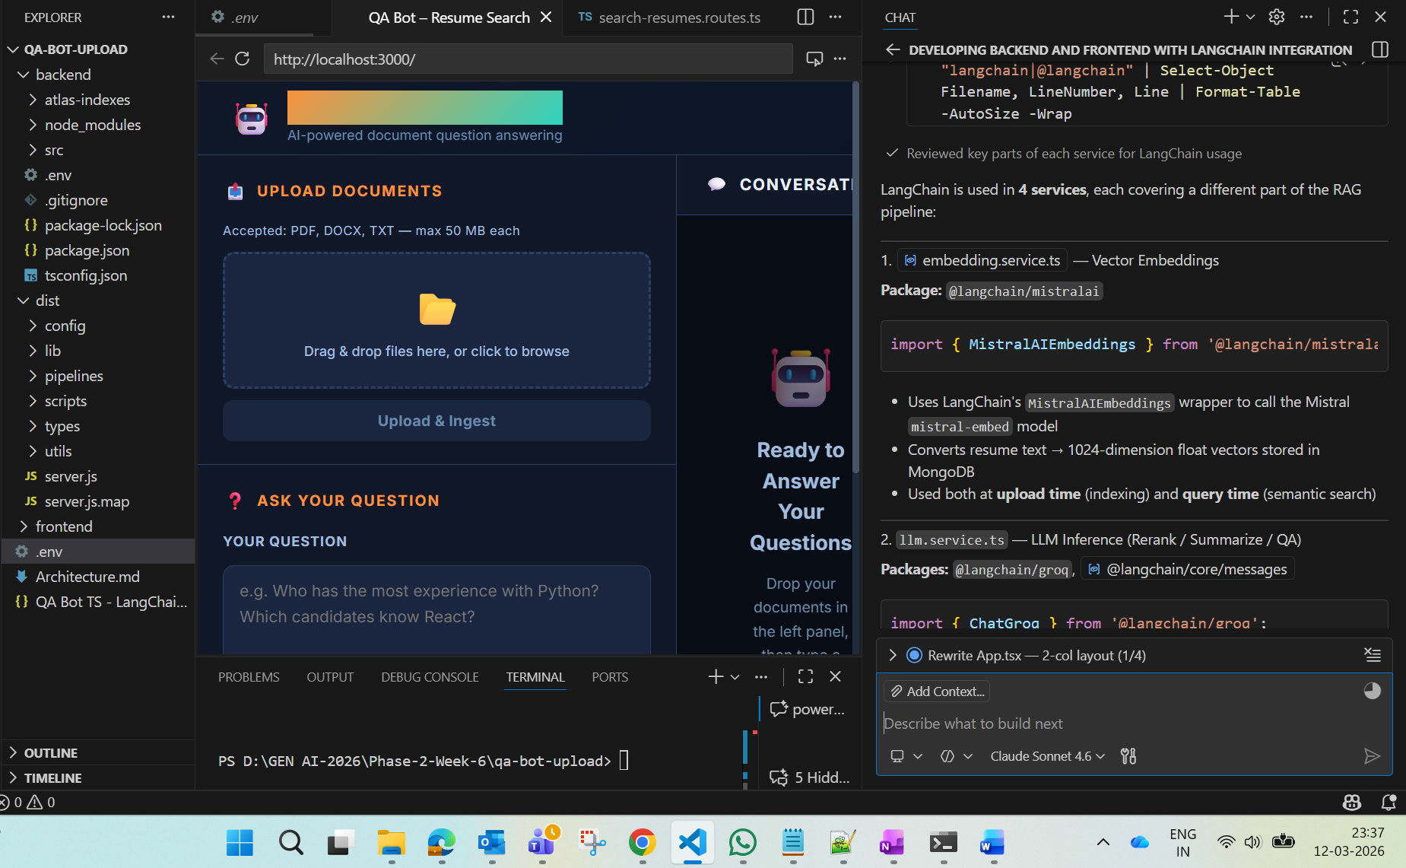
Option to upload multiple files and allow users to ask questions based on the content of the uploaded files.

